**Functions**

Function is a collection of statements which perform an operation.

To define a function we use "def" keyword.

To call a function we use function name.

The Function which is defined for 1 time can call for multiple times.

**Syntax and parts**

**Examples**

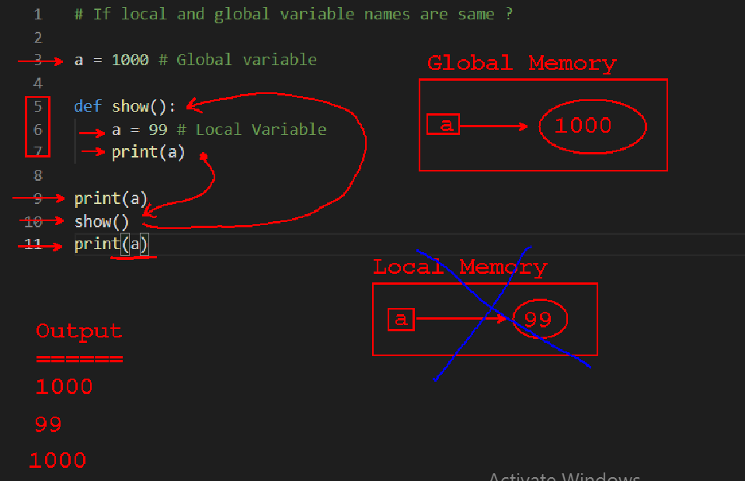

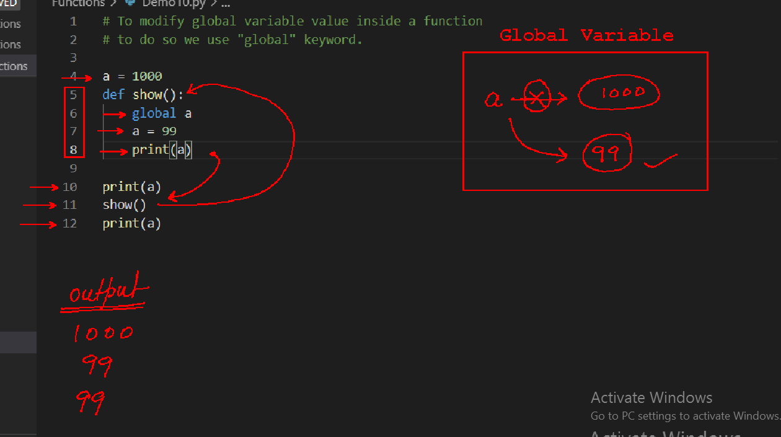

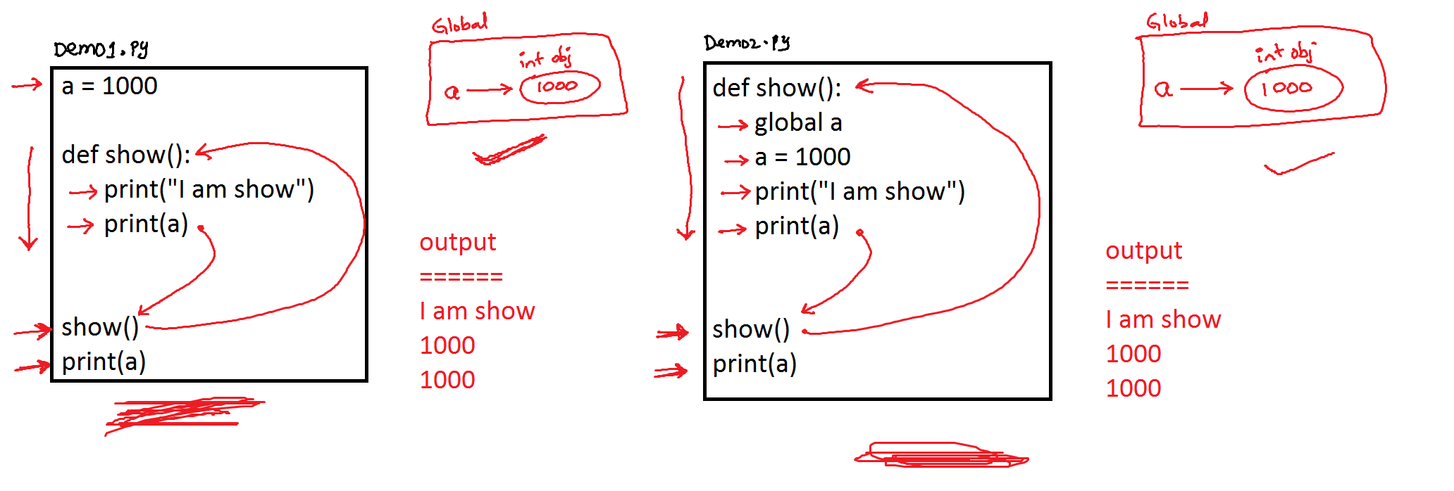

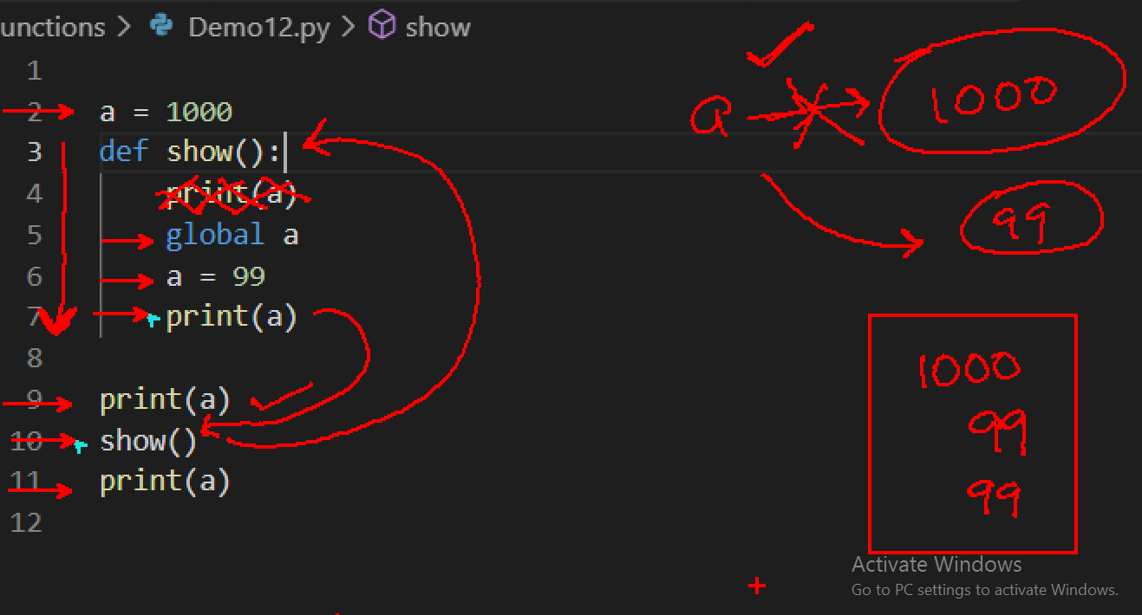

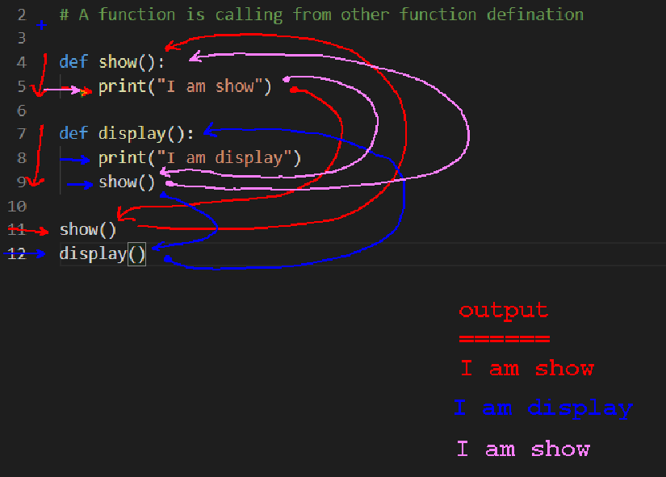

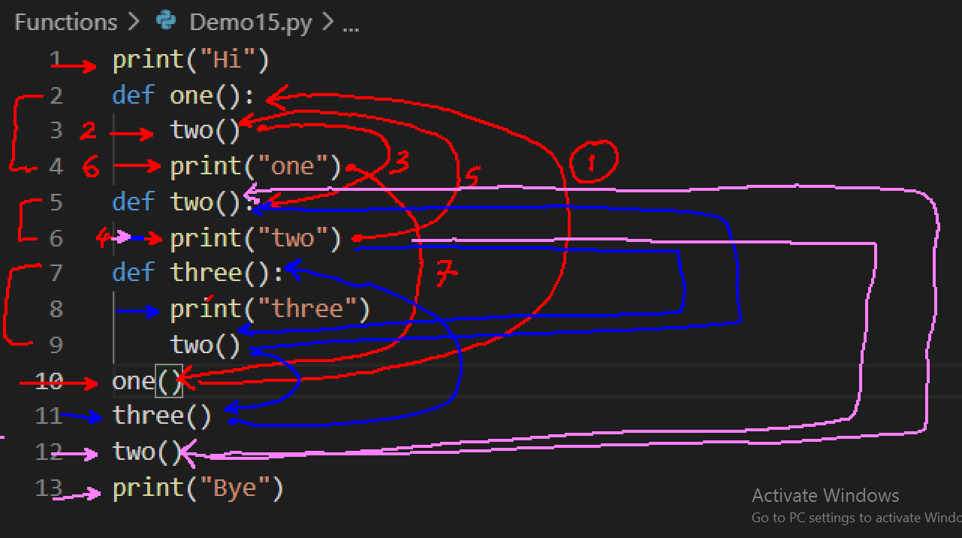

**Parameter**

The variable which is declared inside the function header is called as parameter

The Scope of parameter is within the function body.

Parameter will get memory after function calling.

In Python we have 4 types of Parameters.

1) Required

If a function is defined with required parameter, while calling that function we must pass object else it will return an error.

Example

def display(idno,name):

    print("Display")

    print("Employee IDNO = ",idno)

    print("Employee NAME = ",name)

display(101,"Ravi")

print("-----------------------------")

display("Kumar",102)

print("-----------------------------")

display(name="kumar",idno=102)

2) Default (Non Required)

If a function is defined with Default Parameter, while calling that function its optional to pass object.

def display(idno=0,name=None):

    print("Display")

    print("Employee IDNO = ",idno)

    print("Employee NAME = ",name)

display()

print("-------------------------")

display(101)

print("-------------------------")

display(102,"Kumar")

print("-------------------------")

display(name="Ravi")

print("-------------------------")

display(name="mohan",idno=103)

Example on required and default parameters

def display(idno,name=None):

    print("Display")

    print("Employee IDNO = ",idno)

    print("Employee NAME = ",name)

display(101)

print("-------------------------------")

display(name="Ravi") # Error

print("-------------------------------")

display(name="Kumar",idno=102)

3) Argument Length --> * type(tuple) -- *args

4) Keyword Argument --> ** type(dict) -- **keyargs

In python we can define functions in 4 ways.

1) Function without parameter and without return (0,0)

2) Function with parameter and without return(1,0)

3) Function without parameter and with return.(0,1)

4) Function with parameter and with return.(1,1)